Simulation Training for Faculty using Simulation to Replace Clinical
If you are using simulation to replace clinical, be sure you are a member of the Minnesota Simulation for Healthcare Education Partnership (MnSHEP) which provides multiple free resources for faculty in MN.
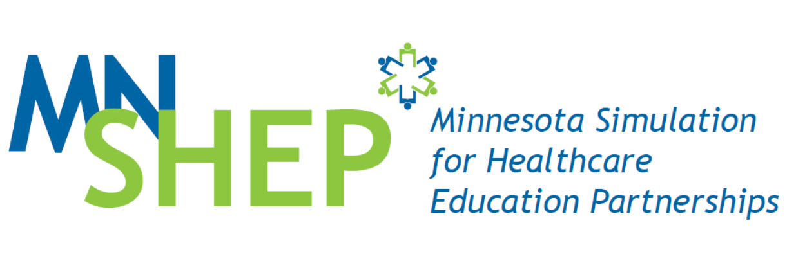
MnSHEP list serve
Become a member of the MnSHEP list serve to receive information on upcoming conferences, workshops, webinars, site visits, simulation, resources, and quarterly newsletters. There is no cost to join! Once you are on the list serve you are considered a member of MnSHEP.


The Minnesota Board of Nursing requires continuing education for
faculty using simulation to replace clinical hours. The legislative rule states:
6301.2340 REQUIRED CRITERIA FOR NURSING EDUCATION PROGRAMS.
Subpart. 3. Nursing education program.
B. High-fidelity simulation may be used in part to meet the requirements of
item A, subitem (4), units (a) and (b), when:
- nursing faculty with documented education and training in the use of
simulation develop, implement, and evaluate the simulation experience;
(5) pre-briefing and debriefing are conducted by nursing faculty with subject matter expertise and training in simulation using evidence-based techniques;

There are the 4 webinars listed on the next page which form a beginning foundation for education and training in simulation.
- Complete the survey at the end of each webinar to receive a certificate for 1 to 1.5 hours of continuing education for each of the webinars.
- There are many free webinars on the HealthForce Minnesota website. Be sure to review the scheduled and archived webinars for your educational needs.

Webinar Title | Links to Webinars, Handouts and Survey for Continuing Education | Date Completed
Webinar Title: The Use of Theory in Simulation | Presenters: Gail Johnson, PhD(c), CPHQ, CHSE, CHSOS and Carol Reid, PhD, MSN, CNE  Click here for link to Webinar  Link to Continuing Education Survey  Handouts are on the HealthForce MN website (link below)
Webinar Title: Pre-briefing: Setting the Stage for Success | Presenter: Jeanne Cleary MA, BSN, RN  Click here for link to Webinar  Link to Continuing Education Survey  Handouts are on the HealthForce MN website (link below)
Webinar Title: Set the Stage for Success as a Facilitator | Presenters: Colleen Royle EdD, RN, and Rose Raleigh MS, RN  Click here for link to Webinar  Link to Continuing Education Survey  Handouts are on the HealthForce MN website (link below
WEBINAR Title: Debriefing in Simulation: Setting the Standard | Presenter: Rose Raleigh, MS, RN  Click here for link to Webinar  Link to Continuing Education Survey  Handouts are on the HealthForce MN website (link below)
Coming December 2018 | Webinar on Evaluation

MnSHEP Website
If a link does not work or to review other webinars:
Go to Health Force MN site: http://healthforceminnesota.org/educators_college/simulation.html
Choose the “secure login”
The Username and Password are the same: Simulation

